Lab 2 :

Task 1 :

I chose sensor tag and modified the code of app1 and app3 such that the text file generated contains time, gps, acceleration, humidity, pressure.

Then I connected sensor tag to nexus 7 and executed the app and recorded the data.

Here is my data record generated.

Task 2 : now we have to push this in Hbase :

Here we will be using Zookeeper and Hbase. So, we should see so that these both are in good health.

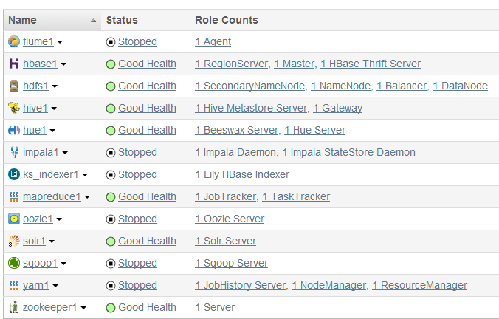

As they are in good health we proceed further.

1. First we would create a table

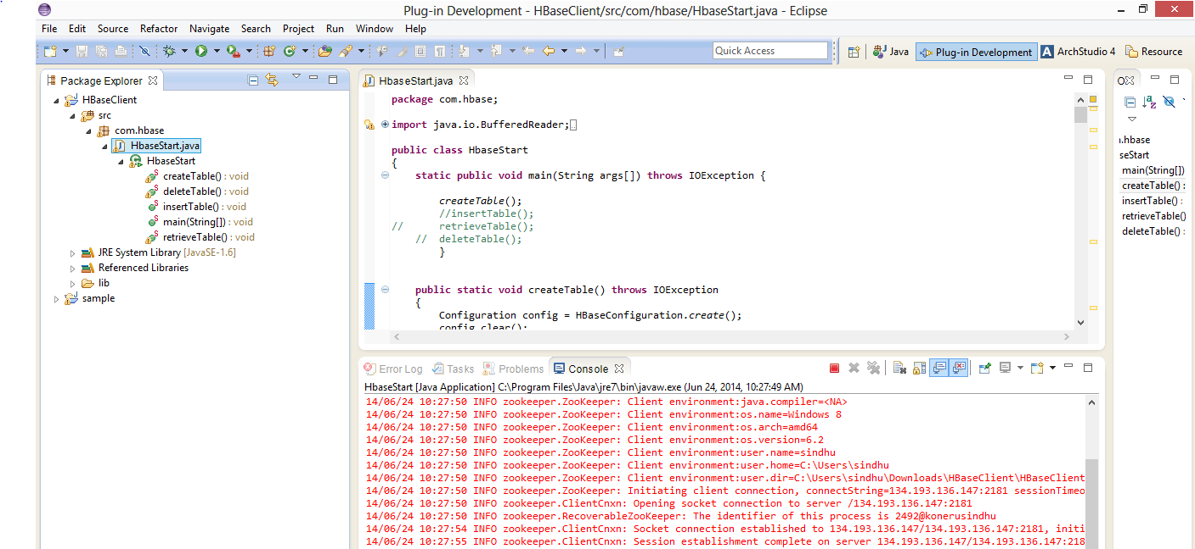

Our table name is SensorTagTableGroup8

It is created in HBase :

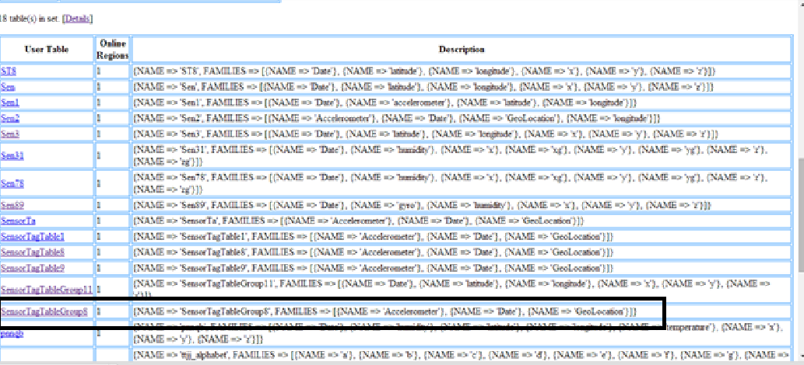

2 )now we insert the data into the created table :

For this we use insert function

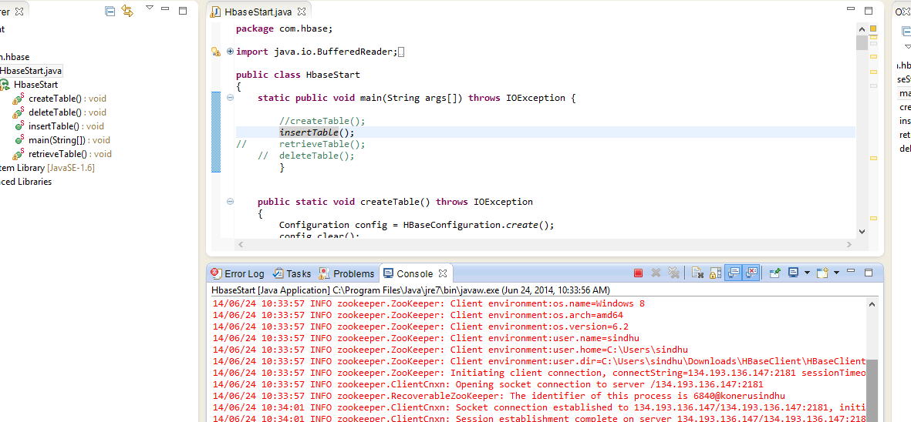

Retrieval of data :

We can retrieve the data .

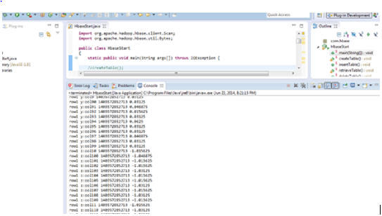

Deleting the table :

After we delete the table by writing particular code. We cannot see it.

